**2021-CSE4IP&CSE5CES**

**Practice Test for the format of Final Test-Solutions**

**Part-1 (30 MCQ ,T/F questions and output) [30 Mark]**

Write what would be printed by the print statement in the following fragment of Python code.

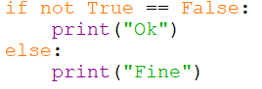

OK

1. Computer can execute the code in ____________.

machine language

assembly language

python language

high-level language

Machine language

1. Python syntax is case-sensitive

True

False

True

1. A Python line comment begins with ________.

//

/*

#

$$

#

1. A Python paragraph comment uses the style ________.

// comments //

/* comments */

/# comments #/

''' comments '''

''' comments '''

1. An identifier/ variable can be a keyword?

True

False

False

1. Which of the following is a valid identifier/variable?

$343

mile

9X

8+9

mile

1. Which of the following is a valid identifier? (choose multiple)

While

Kilo1

Mile

(red)

Mile

1. What will be displayed by the following code?

x = 1

x = 2 * x + 1

print(x)

1

2

3

4

3

1. What will be displayed by the following code?

x, y = 1, 2

x, y = y, x

print(y, x)

1 1

2 2

2 1

1 2

1 2

1. What is the result of 45 / 4?

10

11

11.25

12

11.25

1. Which of the following expression results in a value 1?

2 % 1

15 % 4

25 % 5

37 % 6

37 % 6

1. What is 2 ** 3 evaluates to __________.

8

9

8.0

9.0

8

1. What is x after the following statements?

x = 1 x *= x + 1

1

2

3

4

2

1. Analyze the following code:

even = False

if even:

print("It is even!")

The code displays It is even!

The code displays nothing.

The code is wrong. replace if even: with if even == True:

The code is wrong. replace if even: with if even = True:

The code displays nothing.

1. The following code displays ___________.

temperature = 50

**if** temperature >= 100:

**print**(**"too hot"**)

**elif** temperature <= 40:

**print**(**"too cold"**)

**else**:

**print**(**"just right"**)

too hot

too cold

just right

too hot too cold just right

just right

1. What is the value of the following expression?

**print(True or True and False)**

True

False

True

1. Which of the following operators is right-associative.

+

*

and

=

=

1. How many times will the following code print "Welcome to Python"?

count = 0

**while** count < 10:

**print**(**"Welcome to Python"**)

9

10

11

infinite number of times

infinite number of times

1. What will be displayed when the following code is executed?

number = 6

**while** number > 0:

number -= 3

**print**(number)

6 3 0

6 3

3 0

3 0 -3

3 0

1. The function range(5) return a sequence ______________.

1, 2, 3, 4, 5

0, 1, 2, 3, 4, 5

1, 2, 3, 4

0, 1, 2, 3, 4

0, 1, 2, 3, 4

1. Will the following program terminate?

balance = 10

**while** True:

**if** balance < 9: **break**

balance = balance - 9

Yes

No

Yes

1. Will the following program terminate?

balance = 10

**while** True:

**if** balance < 9: **continue**

balance = balance - 9

Yes

No

NO

1. A function _________.

must have at least one parameter

may have no parameters

must always have a return statement to return a value

must always have a return statement to return multiple values

1. Given the following function

**def** nPrint(message, n):

**while** n > 0:

**print**(message) n -= 1

What will be displayed by the call nPrint('a', 4)?

aaaa

aaa

invalid call

infinite loop

infinite loop

1. What will be displayed by the following code?

**def** f1(x=1, y=2):

x = x + y

y += 1

**print**(x, y)

f1()

1 3

3 1

1 1

3 3

3 3

1. Which of the following functions return 4.0

int(3.4)

int(3.9)

eval(3.4)

round(3.5)

round(3.5)

**Part-2 (6 Short answer) [30 Mark)**

Consider the following function:

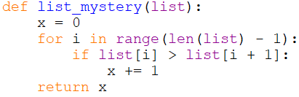

In the left-hand column below are specific lists of integers. Indicate in the right-hand column what value would be returned by function list_mystery if the integer list in the left-hand column is passed as its parameter.

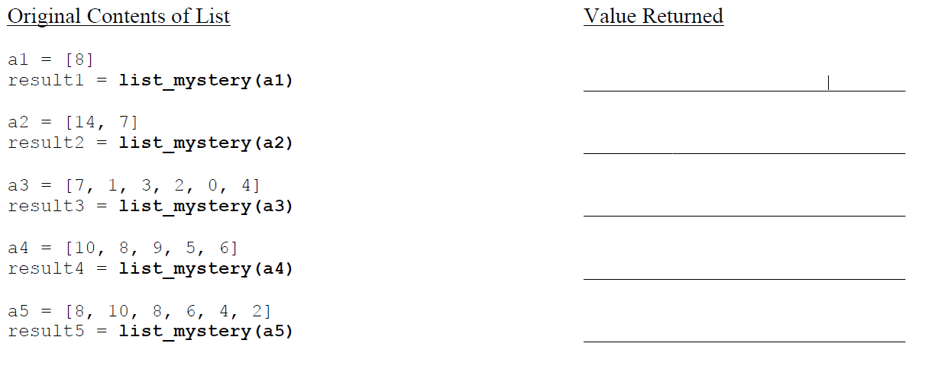

Answer:

0

1

3

2

4

Write the output produced by this program below.

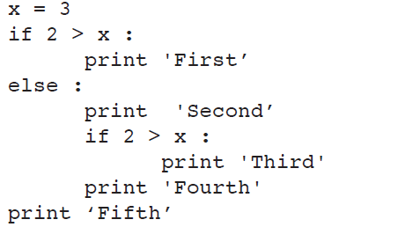

Answer:

Second

Fourth

Fifth

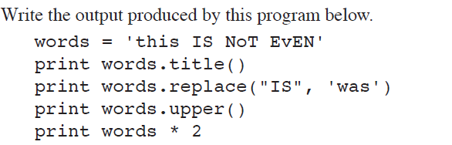

*Answer:*

This Is Not Even

this was NoT EvEN

THIS IS NOT EVEN

this IS NoT EvENthis IS NoT EvEN

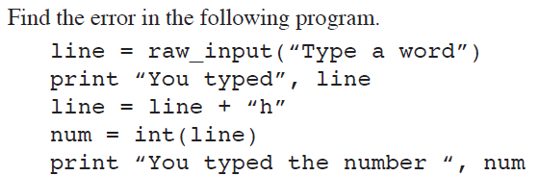 *Answer:*

The problem lies in lines 3 and 4. Line 3 appends a letter (“h”) to the input string. Line 4 then tries to

convert the result to an integer. The result, however, will never be a valid integer because of the letter “h”. So you get an error.